**Knee examination**

|  |
| --- |
| Washes hand/uses Alcohol rub before and after knee examination. |
| * General appearance, vital signs, BMI.   **Inspection:** Gait: deformities (Varus VS Valgus) , Skin changes (scars, redness, rashes, effusion, muscle wasting, any joint deformities), popliteal swelling (Baker's cyst)   * Compares both sides. |
| **Palpation:** Asks if patient is in any pain, assesses skin temperature, palpates joint line and surrounding structures. *Temperature, * Tenderness over ( Tibial tubercle, patella and patellar tendon, joint line, medial and lateral sides of the joint, ?bursitis) * Effusion: *Bulge/Sweep test (for minimal effusion)   * patellar tap test (for large effusion) |
| **Movement**: Examines active and passive flexion and extension, check for crepitus… |
| Assesses cruciate ligament tears (Anterior & posterior drawer tests).  ✓ **Anterior drawer test**: performed with knee in 90° flexion and foot flat on the couch by pulling the tibia anteriorly. **Posterior drawer test:** also performed with knee in 90° of flexion by pushing the tibia posteriorly . |
| Examines popliteal fossa. |
| Performs knee reflex test. |

**INSPECTION**

Erythema, swelling, bruising, lacerations, gross deformity, discoloration, and any asymmetry of bony or soft tissue landmarks, including atrophy and valgus or varus deformi­ties, should be noted.

**PALPATION**

Palpation should assess for pain over all bony and soft tissue landmarks, warmth, and effusion.

**RANGE OF MOTION AND STRENGTH TEST**

Range of motion (active and then passive) should be used to assess flexion and extension of the knee. Normal limits of knee range of motion include extension from 0 to –10° and flexion to 135°.

**PATELLAR TAP TEST**

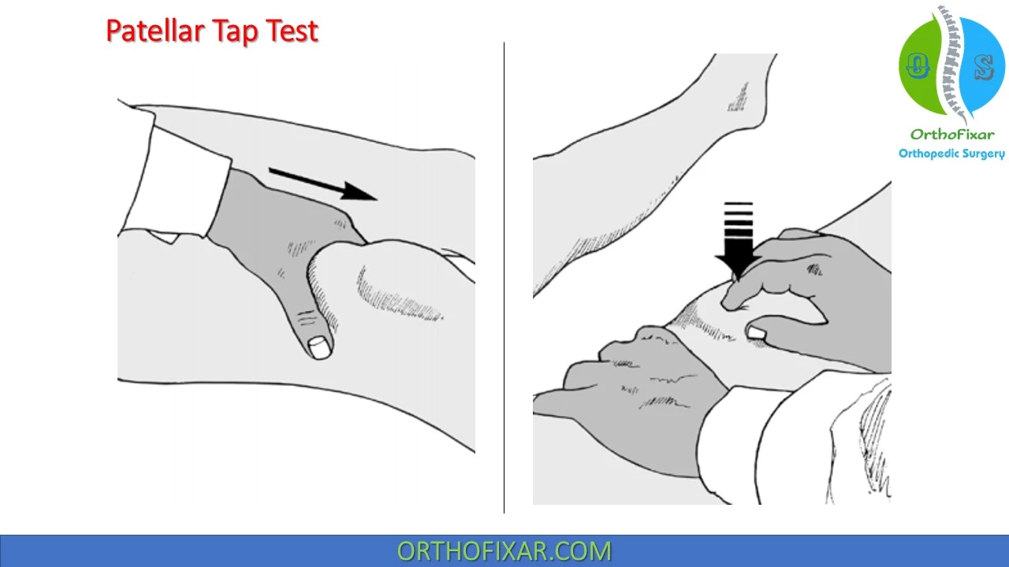

**COLLATERAL LIGAMENT TESTS**



**ANTERIOR & POSTERIOR DRAWER TESTS**

