B. Asthma

1) What is the definition of bronchial Asthma?  
2) What are the symptoms and signs of Asthma?  
3) How do you assess severity of Asthma?  
4) What is the pathophysiology behind Asthma?  
5) Is Asthma reversible?  
6) What investigations would you order for a patient you suspect having Asthma?  
7) What are the parameters you use when measuring the severity of Asthma?  
8) Is Asthma obstructive or restrictive lung disease and what is the difference?  
9) What are some of the drugs we use in Asthma management?  
10) What is the mechanism of the drugs used to reduce Asthma symptoms?  
11) What are some complications that could occur in long lasting Asthma patients?  
12) What does silent chest indicate?  
13) What could be a possible differential diagnosis in a patient suspected with asthma?  
14) What advice would you give an asthmatic?  
15) What is atopy?  
16) What is Churg Strauss syndrome?

1. **What is asthma?**
2. **What is its impact?**
3. **Local reports suggest that the prevalence of asthma is increasing, why is that?**
4. **Why prevalence is increasing among Saudi children?**
5. **What is the Pathophysiology of Asthma?**
6. **How to diagnose asthma?**
7. **What Qs you ask in the history?**
8. **What conditions & medications that worsen symptoms of asthma?**
9. **What you will find in physical examination?**
10. **Asthma control test item, ACT is the sum of the five questions where each is scored from 1 (worst) to 5 (best), leading to a maximum best score of 25. A score of ≥20 indicates controlled asthma, 16–19 partially controlled asthma, and <16 uncontrolled asthma.**
11. **How to diagnose Asthma?**
12. **What are the medication used?**

13. **What are the long-term goals of asthma management?**

14. **What are the triggers factors?**

1. **Assessing asthma control in adults**

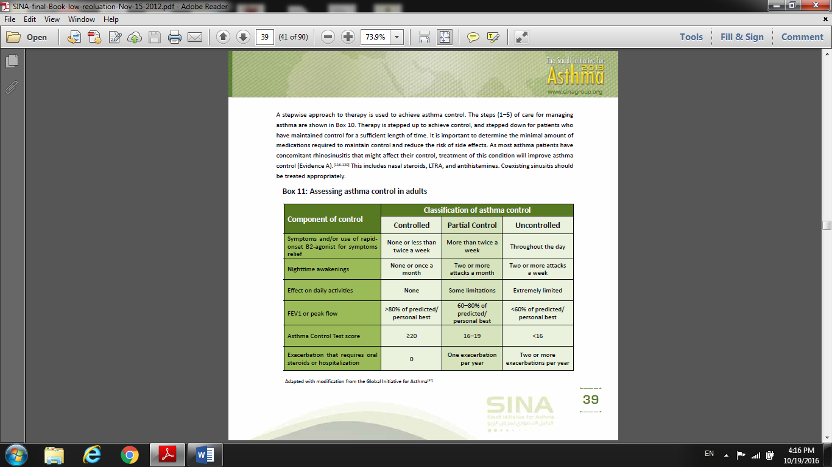

15**. How to maintain control of Asthma?**

16. **If Asthma control is not achieved, which actions are recommend?**

17. **When referral to specialist is recommended?**

18**. What treatment Steps in adult?**

**- Step 1.**

**Treatment at step 2**

**Treatment at step 3**

•

**Treatment at step 4**

**Treatment at step 5**

19. **What should be considered for patients who require long-term systemic corticosteroids**?

20**. How you manage acute asthma in adult?**

1. **Levels of severity of acute asthma exacerbations in adults**

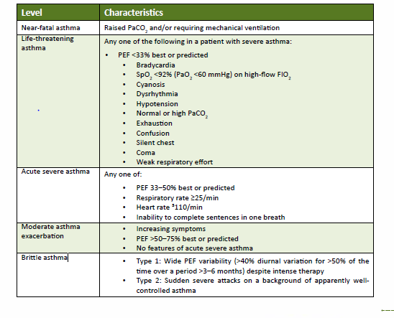

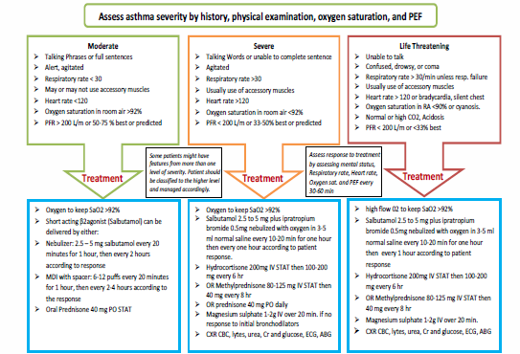c)

**21. For whom ICU referral is recommended?**

22. 1. In outpatient management of asthma in children aged 5–11 years, according to SINA 2016.

- If the child is on short acting beta agonist (prn) + low dose ICS and still not control.

What is the best next option to him?

23. An adult patient known of bronchial asthma, came to the clinic on sulbutamol inhaler + low medium dose of ICS & LABA, his ACT IS 17. During your assessment to the patient, he is adherent to treatment and taking right dose decide to step up his treatment.

- Before you step up medication, which is other important factor to assess?