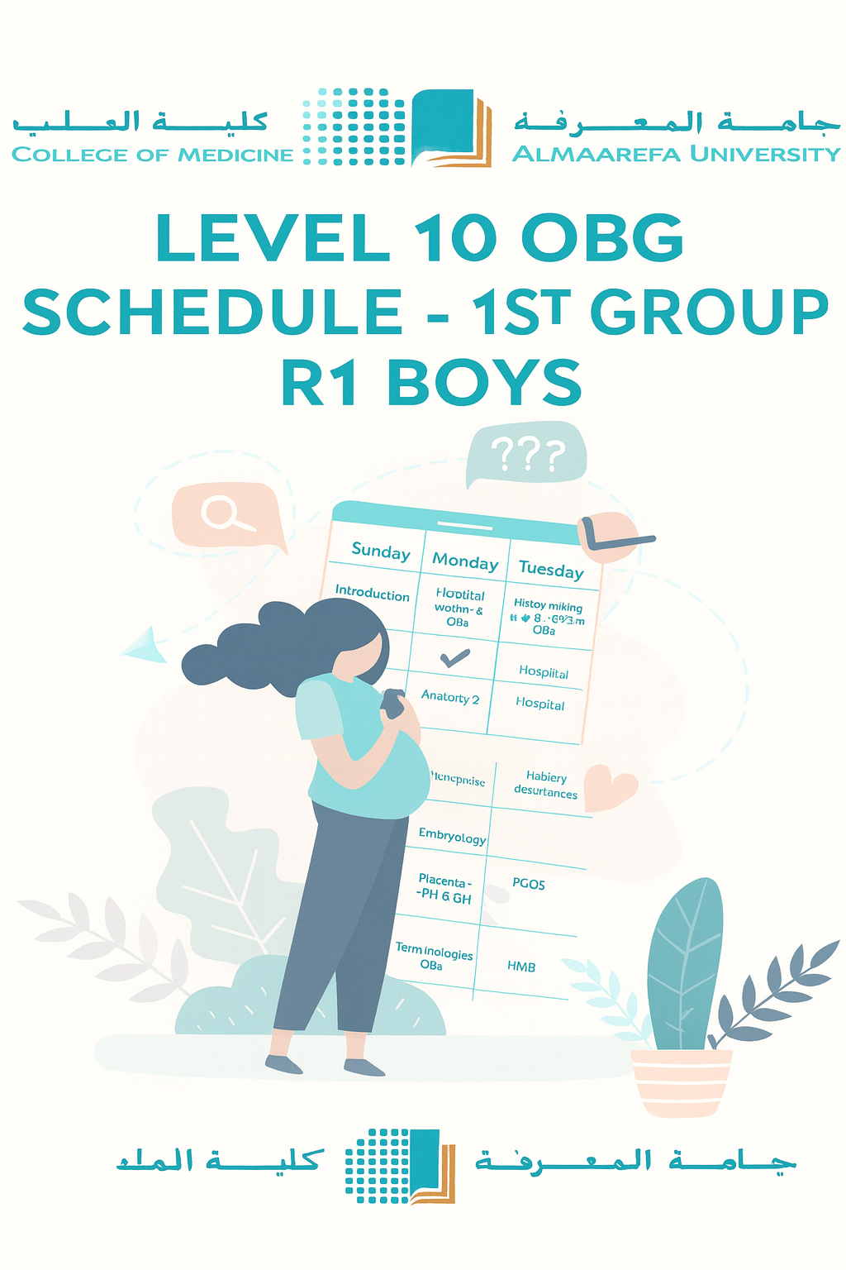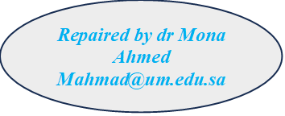

**Course coordinator dr Mona Ahmed**

**mahmad@um.edu.sa**



|  |  |  |  |  |  |
| --- | --- | --- | --- | --- | --- |
| ***1st Week*** | **Sunday** | **Monday** | **Tuesday** | **Wednesday** | **Thursday** |
| 8:00 am | Welcoming &Introduction To Ob/Gyn | Hospital | Maternal Fetal Physiology. L | Hospital | CCTD-  Fetal head |
| 9:00 am | Anatomy Of genital tract & Pelvis . SDL | Hospital | History& Physical Examinations. (GYN)L | Hospital | CCTD- Hx taking & Ex OBS |
| 10:00 am | Embryology Of The Reproductive System. L | Hospital | ANC. L | Hospital | CCTD-  Labour |
| 11:00 am | Menstrual Cycle, Ovulation, Fertilization, Implantation | Hospital | ANC. L | Hospital | CCTD-  Labour |
| 12:00 pm |  |  |  |  |  |
| 1:00 pm | Pubertal disorders | Hospital | Seminar-1:  Hirsutism & virilization. | Hospital |  |
| 2:00 pm | Placenta And Amniotic Fluid | Hospital | Hirsutism & virilization. | Hospital |  |
| 3:00 pm | History& Physical Examinations (OBS) | Hospital | Case discussion-1: PCOS | Hospital |  |
| 4:00 pm | Terminologies obs+Gyn (Self learning) | Hospital | Case discussion: PCOS | Hospital |  |

|  |  |  |  |  |  |
| --- | --- | --- | --- | --- | --- |
| ***2nd Week*** | **Sunday** | **Monday** | **Tuesday** | **Wednesday** | **Thursday** |
| 8:00 am | Legal And Ethical Issues In OBG | Hospital | Puerperium & Lactation | Hospital | CCTD-  Analgesia & Ansthesia |
|  | Dr Rayan |  | Dr Rayan |  |  |
| 9:00 am | PPH | Hospital | APH-Abruptio Placentae | Hospital | CCTD-  Abnormal labour |
|  |  |  |  |  |  |
| 10:00 am | Case discussion-2:  3rd trimester bleeding | Hospital | Case discussion-3:  Abortion | Hospital | CCTD-  Abnormal labour |
| 11:00 am | Case discussion-2:  3rd trimester bleeding | Hospital | Case discussion-3:  Abortion | Hospital | CCTD-  Seminar-4:IOL |
| 12:00 pm |  |  |  |  |  |
| 1:00 pm | Case discussion:  3rd trimester bleeding | Hospital | Seminar-3:  post-partum pyrexia | Hospital |  |
| 2:00 pm | Seminar-2: Fibroid | Hospital | Seminar-3:  Post partum pyrexia | Hospital |  |
| 3:00 pm | Seminar-2: Fibroid | Hospital |  | Hospital |  |
| 4:00 pm |  | Hospital |  | Hospital |  |

|  |  |  |  |  |  |
| --- | --- | --- | --- | --- | --- |
| ***3rd Week*** | ***Sunday*** | ***Monday*** | ***Tuesday*** | ***Wednesday*** | ***Thursday*** |
| *8:00 am* | *Mid-block exam* | *Hospital* | *Rh incompatibility* | *Hospital* | *CCTD*  *Analgesia & Anesthesia In Labor* |
|  |  |  |  |  |  |
| *9:00 am* | *DUB* | *Hospital* | *Post partum anxiety & depression* | *Hospital* | *CCTD*  *Fetal Distress* |
| *10:00 am* | *Recurrent miscarriage* | *Hospital* | *Preterm labour* | *Hospital* | *CCTD*  *Abnormal labour* |
| *11:00 am* |  | *Hospital* | *PPROM* | *Hospital* | *CCTD*  *Abnormal labour* |
| *12:00 pm* |  |  |  |  |  |
| *1:00 pm* |  | *Hospital* | *Case discussion- 4:*  *IUFD* | *Hospital* |  |
| *2:00 pm* |  | *Hospital* | *Case discussion- 4:*  *PMS* | *Hospital* |  |
| *3:00 pm* |  | *Hospital* | *Semiar-5: Postterm pregnancy* | *Hospital* |  |
| *4:00 pm* |  | *Hospital* |  | *Hospital* |  |

|  |  |  |  |  |  |
| --- | --- | --- | --- | --- | --- |
| ***4th Week*** | ***Sunday*** | ***Monday*** | ***Tuesday*** | ***Wednesday*** | ***Thursday*** |
| *8:00 am* | *DM*  *Macrosomia* | *Hospital* | *HTN &*  *PTE* | *Hospital* | *CCTD -Instrumental delivery* |
|  | *Dr Rayan* |  |  |  |  |
| *9:00 am* | *Multiple pregnancy* | *Hospital* | *IUGR* | *Hospital* | *CCTD*  *Fetal malpresentation* |
| *10:00 am* | *Seminr-6:*  *Dysmenorrhoea* | *Hospital* | *Infections in pregnancy* | *Hospital* | *CCTD-*  *Neonatal resuscitation* |
| *11:00 am* | *Seminar -7:*  *C-Section* | *Hospital* | *Infections in pregnancy* | *Hospital* | *CCTD-*  *Radiology in OBG* |
| *12:00 pm* |  |  |  |  |  |
| *1:00 pm* | *Case discussion-PID* | *Hospital* | *Case discussion:*  *EP* | *Hospital* |  |
| *2:00 pm* | *Case discussion-PID* | *Hospital* | *Case discussion:*  *Surgical conditions in pregnancy* | *Hospital* |  |
| *3:00 pm* |  | *Hospital* | *Seminar:*  *vulvovaginitis* | *Hospital* |  |
| *4:00 pm* |  | *Hospital* |  | *Hospital* |  |

|  |  |  |  |  |  |
| --- | --- | --- | --- | --- | --- |
| ***5th Week*** | *Sunday* | *Monday* | *Tuesday* | *Wednesday* | *Thursday* |
| *8:00 am* | *Medical conditions: Epilepsy-AFE* | *Hospital* | *CPP* | *Hospital* | *CCTD-*  *Operations in gyn* |
| *9:00 am* | *Medical conditions:*  *Asthma -CVD* | *Hospital* | *Urinary incomitance* | *Hospital* | *CCTD-*  *Cord prolapse.-ECV* |
| *10:00 am* | *Renal (UTI)-GIT(NVP)-Cholestasis)* | *Hospital* | *GTN* | *Hospital* | *CCTD-*  *Instruments* |
| *11:00 am* | *Medical conditions:*  *Thyroid diseases* | *Hospital* | *GYN Ca* | *Hospital* | *CCTD*  *Seminar: Contraception* |
| *12:00 pm* |  |  |  |  |  |
| *1:00 pm* | *Medical conditions:*  *IDA-SCD* | *Hospital* | *Endometriosis &Adenomyosis* | *Hospital* |  |
| *2:00 pm* | *Case Discussion:*  *Menopause &HRT* | *Hospital* | *Seminar:*  *Infertility & ART* | *Hospital* |  |
| *3:00 pm* | *Amenorrhoea* | *Hospital* | *Case discussion: POP* | *Hospital* |  |
| *4:00 pm* |  | *Hospital* |  | *Hospital* |  |

|  |  |  |  |  |  |
| --- | --- | --- | --- | --- | --- |
| ***6th Week*** | *Sunday* | *Monday* | *Tuesday* | *Wednesday* | *Thursday* |
| *8:00 am* | *Logbook assessment* |  | *MCQS* | *CS - SS* | *OSCE* |
| *9:00 am* |  |  |  |  |  |
| *10:00 am* |  |  |  |  |  |
| *11:00 am* |  |  |  |  |  |
| *12:00 pm* |  |  |  |  |  |
| *1:00 pm* |  |  |  |  |  |
| *2:00 pm* |  |  |  |  |  |
| *3:00 pm* |  |  |  |  |  |
| *4:00 pm* |  |  |  |  |  |

***Best wishes***