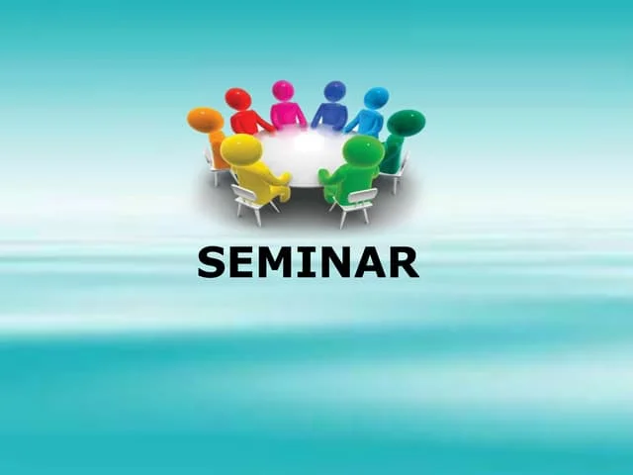

**Seminar Topic Learning objectives \***

**1.Induction and Augmentation of Labor 2**

- Differentiate between induction and augmentation of labor.

- Explain the indications and contraindications of induction and augmentation.

- Describe the different methods of induction.

- Apply Bishop scoring in clinical decision-making.

|

**2.Postpartum Pyrexia 4**

- Define postpartum pyrexia.

- Identify the risk factors.

- Conduct a detailed history and physical examination.

- Formulate a differential diagnosis.

- Plan appropriate investigations.

- Propose a management plan.

|

**| 3. Post-Term Pregnancy 2**

- Recall the normal duration of gestation.

- Analyze the complications of prolonged gestation.

- Evaluate a patient with prolonged gestation.

- Recommend appropriate management options.

**4.Cesarean Section (C/S) 4**

- Define cesarean section.

- Discuss incidence and epidemiology.

- Identify the indications.

- Describe the types of cesarean incisions.

- Analyze the possible complications.

- Plan counseling regarding future reproductive health.

|

**5.Dysmenorrhea 3**

- Define dysmenorrhea and differentiate between primary and secondary types.

- Explain the pathophysiology.

- Identify etiologies.

- Plan appropriate investigations.

- Design a management plan.

|

**6.Vulvovaginitis 3**

- Describe vaginal physiology and bacteriology.

- Perform history and physical examination.

- Formulate a differential diagnosis.

- Plan relevant investigations.

- Propose a management plan.

|

**7.Fibroid Uterus 4**

- Define uterine fibroids.

- Describe pathogenesis.

- Classify types of fibroids.

- Conduct history and physical examination.

- Formulate a differential diagnosis.

- Design medical and surgical management plans.

|

**8.Family Planning, Contraception & Sterilization 5**

- Classify contraceptive methods.

- Explain mechanism of action and effectiveness.

- Counsel patients regarding benefits, risks, and failure rates.

- Describe barrier methods of contraception.

- Recommend strategies to reduce unintended pregnancies.

- Describe male and female sterilization procedures.

- Evaluate risks and benefits of female sterilization.

- Discuss non-pharmacological family planning methods.

|

**9.Hirsutism and Virilization 4**

- Identify normal and abnormal variations in secondary sexual characteristics.

- Define hirsutism and virilization.

- Explain the pathophysiology.

- Identify etiologies.

- Plan appropriate investigations.

- Propose initial management options.

|

**10.Infertility and Assisted Reproductive Technology 4**

- Define infertility.

- Describe causes of male and female infertility.

- Review normal semen analysis findings.

- Interpret abnormalities in semen analysis.

- Plan investigations for infertile couples.

- Propose initial management.

- Appraise psychosocial issues and IVF complications.

**11.Hormonal Replacement Therapy (HRT) 3**

- Identify types of HRT.

- Explain indications and contraindications.

- Describe short- and long-term benefits.

- Analyze complications.

- Outline prerequisites before initiation.